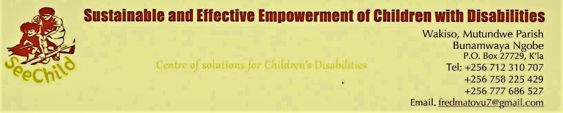
MPIGI INTERGRATED SKILLS TRAINING CENTRE
READY FOR LAUNCH IN FEBRUARY 2023

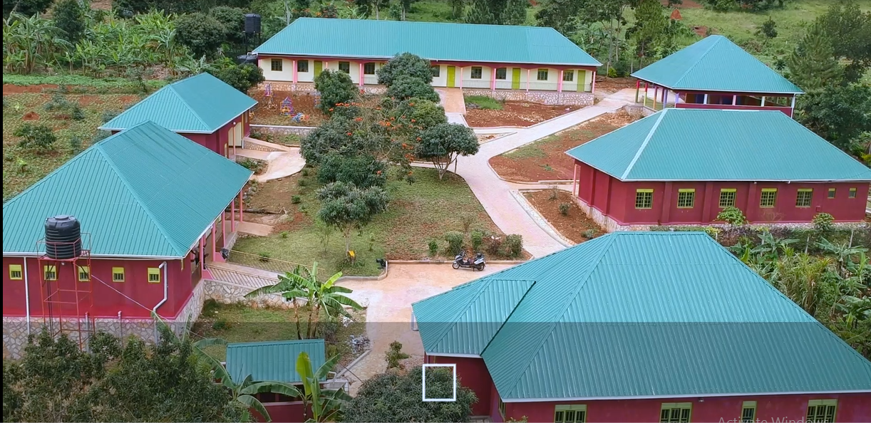

Mpigi Integrated Skills Training Centre opened her operational activities after the completion of construction works in September 2022.

Great appreciation is going to our donor CONGRAVA (Sisters of Breda) and the implementation team led by the Tusaidiane Trust. The site looks gorgeous as you can see in the aerial photo above and several pictures below take during the completion of constructions last year.

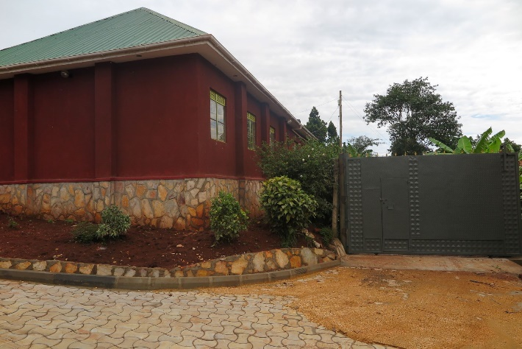  Well-secured entrance with electricity supply | 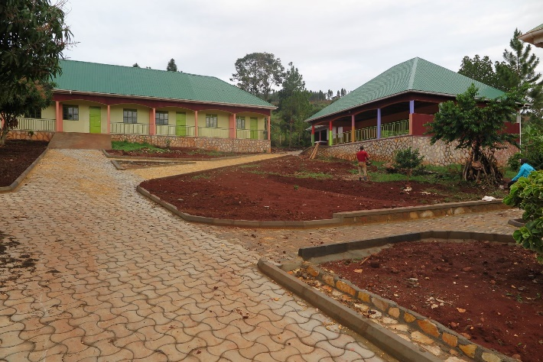  Classrooms and Dining Hall with Kitchen
The first term commenced in September 2022 with one student called Muwonge Joseph who suffers from muscular dystrophy. We recruited two more staff namely the Patron and a trainer Mildred to support the Centre manager and the Guard.
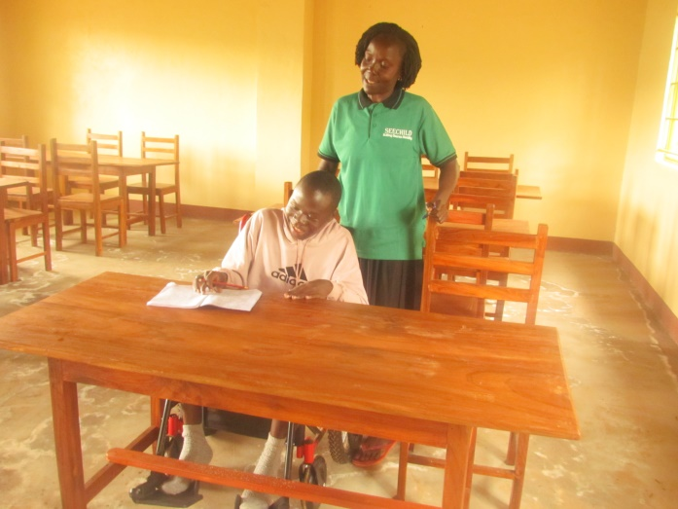  Mildred at work |  | 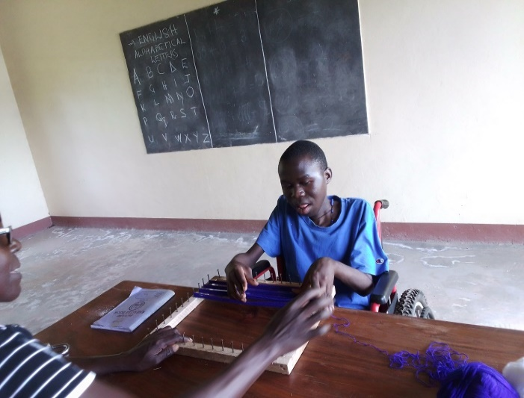  Muwonge Joseph
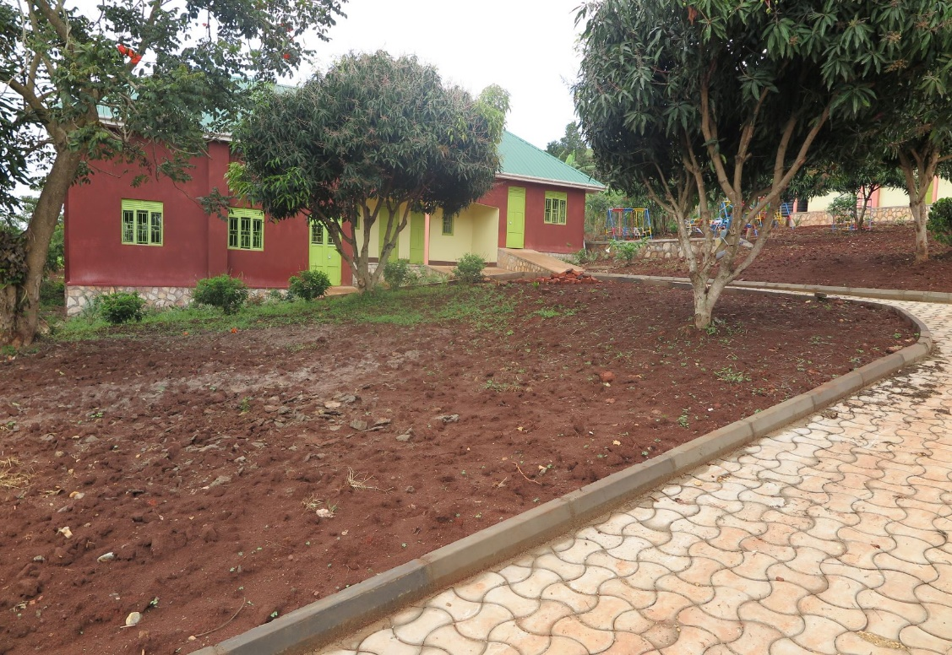  Library, Administration and playing area for the kids |  |  | In the meantime, the operational team has been doing a lot of work to publicize the centre and also register the potential applicants for the second term.  The team being led by the Cordinator of SEECHILD has been hosted on various radio programs namely Radio Maria, Radio Sapientia and CBS to mention but a few.
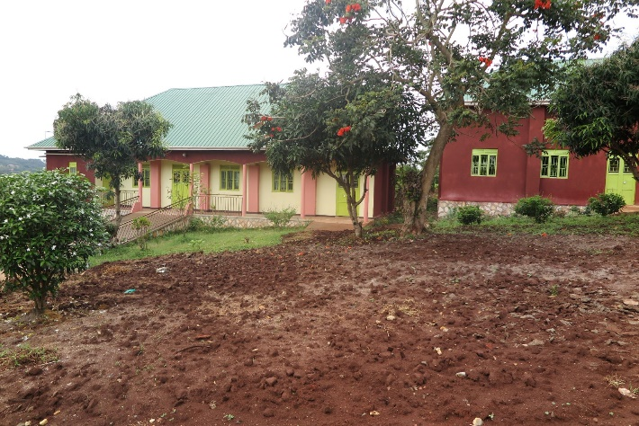  The Boys Dormitory at the left | 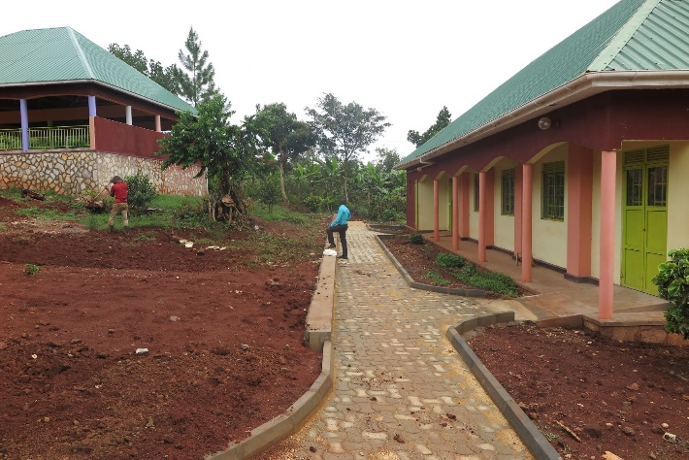  The Girls Dormitory at the right
We have printed out brochures and posters which are being distributed to potential clients. SEECHILD, assisted by Mr. Ivan Tomsange of Tusaidiane, developed a mini documentary for SEECHILD activities.
This mini documentary provides any outsider a quick understanding of SEECHILD activities.

Meanwhile, around 30 boarders (… girls and … boys) have registered for admission in January 2023.

We want to express our sincere appreciation to the donor who accepted to pay for the overruns and because of that we are now able to prepare for the:

Official launch

which will take place on 11th February 2023

The Chief Guest will be the Archbishop of Kampala

Paul Ssemogerere

We have also invited many government officials including two ministers and several members of Parliament.

Vote of Thanks
We thank God that SEECHILD as an Organization is continuously registering an impressive record in the service to vulnerable children, specifically those living with disabilities. All this has been possible because of our supportive and encouraging working partners namely: Mirembe Foundation, CONGRAVA (Sisters of Breda), Wereld Missie Hulp, Tusaidiane Trust and Uganda Limited to mention but a few. We are also very grateful to our staff who generously give themselves to the service of the children.

